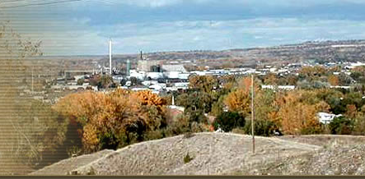

Lockwood Steering Committee
Lockwood School Administration Building

March 28, 2013

Attendees: Don Reed; Ryan Lusin; Corky Harkins; Dan Belk; Glen Seavy; Darold Dent; Mike Linder, County Sheriff; Earl Blakely; Ron Hanson; Brian Renolds; Bob Riehl

Don called the meeting to order at 7 PM.
- LEGISLATIVE REPORT: HB634, Don reported that this bill that would provide voters in large K-8 school Districts like Lockwood SD26 could through voter approval expand to a K-12 District. This bill is still alive in the House Committee on Education. HB 437, which would have provided for districts within a county to provide sidewalks, trails and lighting, has been tabled in Senate Committee on Local Government and is likely to die in committee. The request for an Attorney General’s opinion on the powers of an urban transportation district has been submitted by the Commissioners and the County Attorney.

- Montana Economic Development Association: Chris Mehus attended the meeting and reported on the capability of a MEDA Community Assessment. Members of the Steering Committee met with Gloria O’Rourke, the coordinator for MEDA assessments and will contact her again to plan for a Fall/Winter survey for Lockwood. The group agreed that summer would not be a good time to have such a survey and a good plan needs to be developed to involve a thorough and meaningful portion of the Lockwood community to gain useful information. Don will contact Gloria to setup more planning meetings through the spring and summer. Corky presented a flyer to the group and we encourage all attending the Steering Committee meetings to bring more members of the community.

- Water and Sewer; Dan Belk reported that the District is pursuing more funding for Phase II and proceeding with the Phase I construction in the Superfund area with a low pressure pumped system.

- SCHOOLS: Don Reed said that there are 5 seats on the School Board affected by this spring’s vote. There are 3 three-yr. seats open, 1 two-yr. seat and 1 one yr. seat. Also, there will be a Building Reserve mill levy election as well on the May ballot. There will be an annual amount of $75,000 requested primarily to upgrade the school’s security system. Following an assessment of the school’s security during a consultation with the Yellowstone County Sheriff’s Office, it was determined that prevention of a situation involving an armed intruder is a high priority.

- IRRIGATION DISTRICT: Bob Riehl reported that cleaning and burning of the ditches will begin in April. There has been a request for early start-up of the ditches. It is being considered but, at this time the normal start-up date of May 20th is projected.
- Transportation: No report.
- NEXT MEETING will be April 25th.
Meeting adjourned at 8:45 PM

