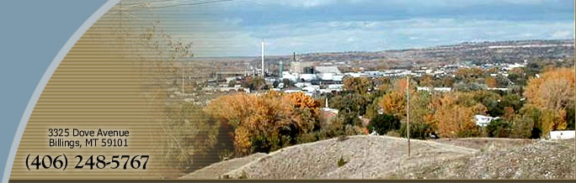

Lockwood Steering Committee
Lockwood School Administration Building

November 21, 2013

Attendees: Don Reed, Conrad Stroebe, Laura Holmlund-Riverside Health, Teresa Stroebe, Brandy Dangerfield, Nic Talmark, Dianne Lehm-BSEDA, Scott Muilenburg, Barb Pedula, Chris Risser, Corky Harkins, MT Representative Jonathan McNiven, Nikki Tetrault, Linda Green, Valerie Dangerfield, Bob Riehl

Don called the meeting to order at 7 PM.
- Introductions and Don welcomed the new attendees gave a short synopsis of the Steering Committees history and expectations for the future. He also announced that he would be stepping down as Chairman at the end of the School year.
- Fire District – no report.
- Water/Sewer – no report
- Irrigation – Bob Riehl reported that Carl has been fielding many calls on the irrigation assessments as the new tax statements are now out. The District had a 10% increase in the current rates which were Administration Fee of $60 increased to $66/tax code/year, Ag usage rate was $15/acre increased to $16.50/acre/year, non Ag usage increased from $40/lot to $44/lot/year. However, most concerns expressed by the customers were actually for corrections on the application of the rates which had been inconsistently applied in the past. The Board is taking the comments into consideration and has contracted with Performance Engineering & Consulting to do a rate analysis for possible rate changes in the future.
- School – Don reported on some of the activities of the School/Education subcommittee. It was proposed that they look for a Chairman that is not School Staff. He will be talking with the group. Teresa Stroebe gave a High School update. As we move to the Legislative Session in 2015, Rep. McNiven suggested that Lockwood needs a petition with many signatures to support a legislative change to the existing moratorium on new high schools. December 5th is the Family Fun Night at the school and an opportunity to get parents involved with this effort.
- Image and Media/Lions Lair - Nikki Tetrault reported that the two subcommittees have decided to separate functions rather than keep them together. The immediate need is for the Lions Lair and Rob Guzman will lead that group. Demolition Day is scheduled for May 10th They have received contributions that will be managed from the PTA. It includes a $25 thousand grant from EXXON Mobile. They have planned a Dec 12th meeting to focus on fund raising. The Image and Media group will meet after the holidays. Nikki is leading the group and they have several projects planned: 1. Signs for the entrance to Lockwood; 2. Bumper Sticker fund raiser; 3. Businesses and Residents should use “Lockwood, MT 59101” in their mailing addresses. The US Post Offices recognizes this address and it will build on Lockwood pride. As the “This and That” subcommittee only has 4 members, the Image and Media group is considering merging with that group.
- Business – Bob Riehl reported that the group began meeting at 7 AM on the first Wednesday of November. They have a Breakfast meeting in the Hitt’s the Spot Café at the Billings Livestock Commission. Notes from the first meeting were shared with the group. They are currently focused on increasing the Businesses attending. Everyone is to bring another business to the next meeting. The next meeting is 7AM December 4th.
- Governance – Linda Green reported the first meeting had very low attendance and they determined that they need better communication. They have 20 folks on their list and will be contacting them directly. Will use the Lockwood Website, phone tree and other means to get folks to attend the next meeting which is 7 PM December 3rd at the Coffee Room of the Lockwood Harvest Church.
- Streets and Paths – Brandy Dangerfield and Nic Talmark reported that they met on November 12th and presented a 2 page list of group concerns, draft list of funding sources and information resources. They are suggesting that we use Bike Net Montana to do some education in Lockwood in January. We discussed the County Commissioner’s proposed Sidewalks, Trails and Lighting district and requested that the subcommittee take the lead on that activity. The folks from the Steering Committee agreed to attend the next Streets and Paths subcommittee to discuss more of the questions and concerns of the group and provided background on current activities.
- Treasurer’s report – Bob Riehl provided a handout showing the expenses, revenues and the remaining balance for the MEDA activities. Remaining Balance as of November 1st was $913.34. With one receipt for gas reimbursement of the Trolley for $50.64. Payment was approved.
- NEXT MEETING will be December 19th ?
Meeting adjourned at 8:50 PM

